# New Year Party Poppers

In this game we’ll be shooting party poppers at Aliens on New Year’s Eve. Press the space bar to pop the popper and hit as many Aliens as you can in 10 seconds.

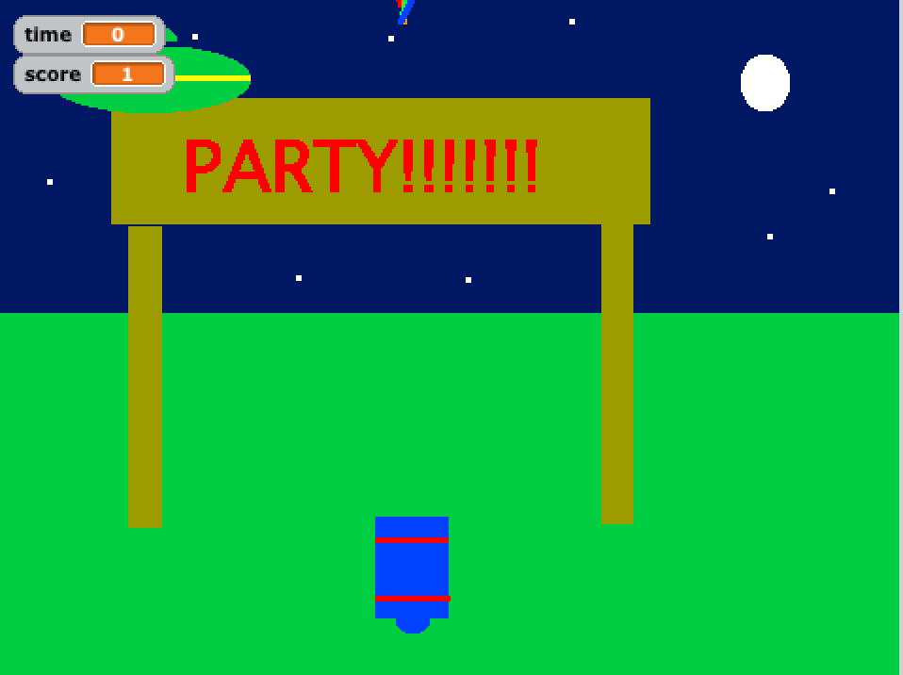

**1. Paint a Background**

First we need to paint a background for the part. This can be anything you like. Select the Stage, then the backgrounds tab and click Paint

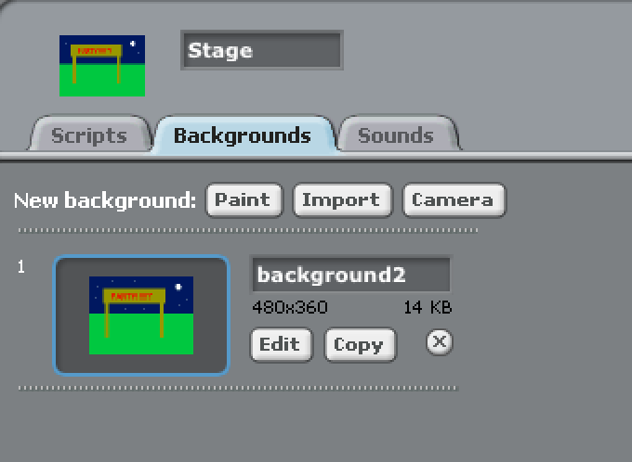

## 2. Create 3 separate Sprites

We’ll need to create three sprites for this game. You’ll need to draw an Alien, a part popper and a pop that shoots out of the popper. Make sure you name the sprits, when you are done they should look like this.

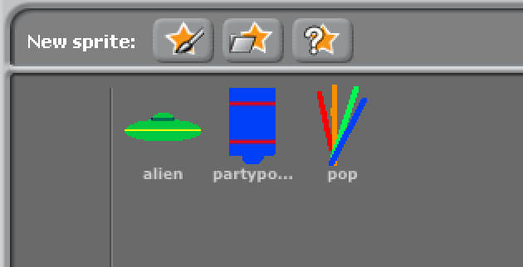

## 3. Create 2 Variables (FOR ALL SPRITES)

We’ll need two variables for this game. Click the variables button and add one called **Time** and one called **Score**.

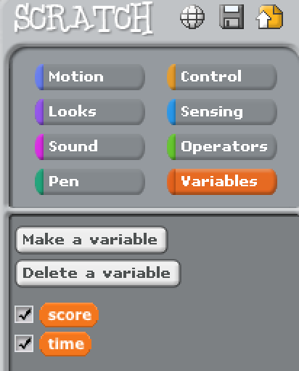

### 4. Write Scripts

Now we’ll need to add the scripts to make the game work. Make sure the **pop** sprite is selected and add the following scripts.

**Script for the pop Laser**

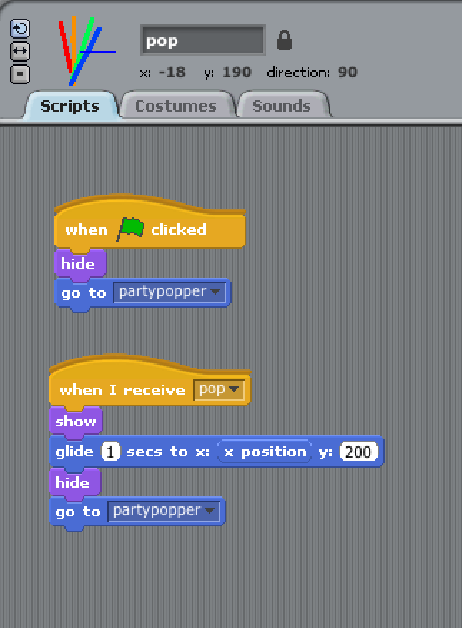

**Script for the Alien Laser**

Now select the **Alien** and add the following Scripts

